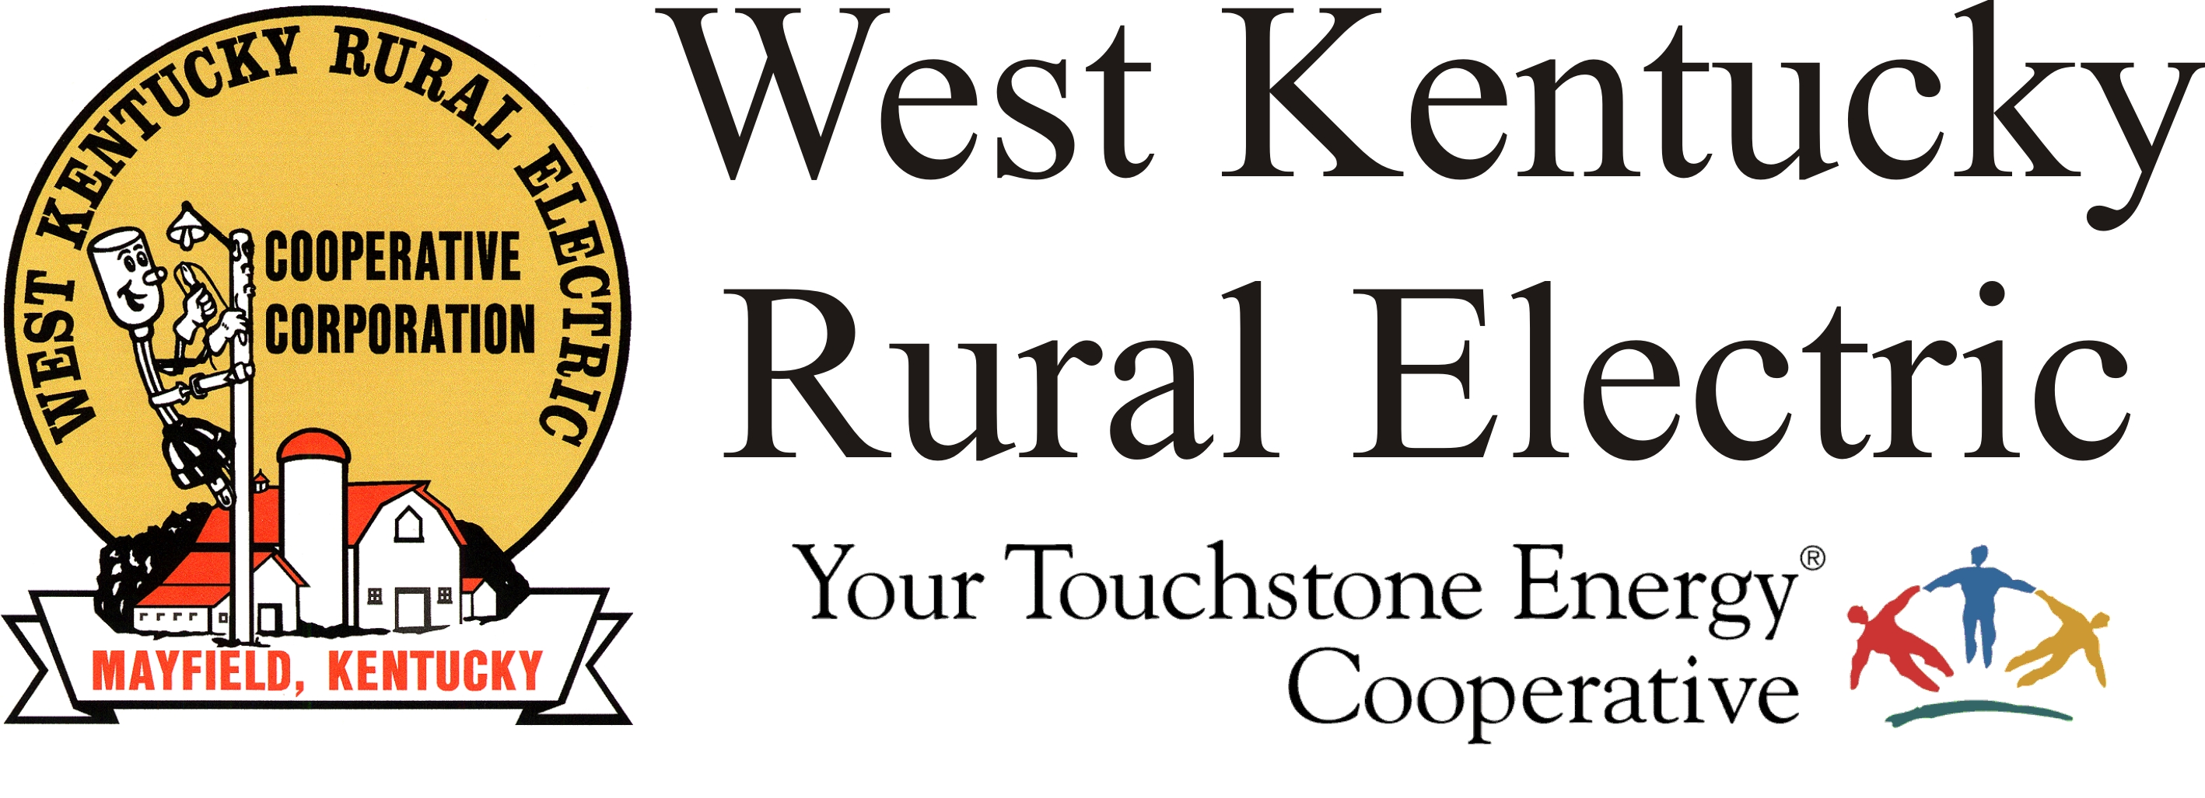

West Kentucky RECC Thursday Morning
Storm Damage Update

(Mayfield, Ky.) Dec. 16, 2021 (8:30 a.m.) – Our outage number is lingering around 400 again this morning. We expect the number will continue to drop slowly through the weekend. Today crews are focusing on the Moors Camp Highway and Oak Level areas in Marshall County, and continuing cleanup work around Mayfield.
Our team of engineers is in the Cambridge Shores area working house-to-house to plan and design a new system of poles and lines to replace those destroyed by the tornado.
We salute our neighbor and public power partner Mayfield Electric, Water and Sewer for making big strides in their restoration efforts on Wednesday.
The Mayfield office will reopen Monday, Dec. 20 at 7:00 a.m. The Murray and Benton offices are open daily from 7:30 a.m. to 4:00 p.m. Customer service is available at 1-877-495-7322. All three payment kiosks are working and our website is up and available for online payments. We are not charging credit card fees. Disconnects for non-payment are temporarily suspended. We will announce when disconnects resume.
To report an outage, call 1-877-495-7322 and use option 1 to leave a recorded message.
Members are advised to continue to be on alert for scams. If you receive a call demanding payment and threatening to disconnect your service, don’t be a victim, just hang up.
___________________________________________________________

Georgann Lookofsky, 270-804-1701 or glookofsky@wkrecc.com

